**Continental patterns in microbial community, metabolite, and geochemical diversity**

Dear Proposal Committee,

My name is Manya Weintraub and I am an undergraduate in Environmental and Sustainability Sciences. I have developed my own concentration centering around agriculture and climate change. To supplement my studies I am gaining hands-on experience working in Dr. Johannes Lehmann’s lab along with Dr. Laurel Lynch and Dr. Itamar Ariel-Shabtai, in the division of Soil and Crop Sciences. We are currently working on elucidating the links between soil biogeochemical properties, microbial communities and microbial metabolites -  a primary building block of soil organic matter. We plan to sample soils across the continental US, spanning soil orders, climates and biomes. The soil samples will be analyzed using biogeochemical, metagenomics, and metabolomics approaches. We will leverage these data streams to investigate how climatic and geographical settings drive soil biogeochemical processes and how these soil properties shape the abundance and diversity of microbial communities and metabolites. This work allows us to test fundamental ecological principles related to soil fertility (Li et al., 2018), and biogeochemical cycling (Doetterl et al., 2015), as well as understanding how environmental parameters affect the functional composition of soil decomposers (Fierer et al., 2016).

**Background |** Soil contains more organic carbon than the atmosphere and global vegetation combined (Lehmann and Kleber, 2015), making it a substantial potential sink for atmospheric CO2 (Paustian et al., 2016). Moreover, soil organic carbon (SOC) helps retain nutrients and water and improves soil structure, which improves plant growth and protects against soil erosion and desertification. Our current understanding of SOC dynamics posits that carbon (C) turnover is largely affected by microbial decomposition of plant and root detritus and exudates (Liang et al., 2017), which results in some C lost as CO2and some retained by microbes (Cotrufo et al., 2013). Microbial products (referred to as water soluble microbially-derived organic compounds) become less accessible to further decomposition as they interact with soil mineral surfaces (Kaiser and Kalbitz, 2012; Keiluweit et al., 2015), and therefore tend to accumulate and to make up a large fraction of the SOC (Lehmann et al., 2008; Miltner et al., 2012). Clearly, microbial community diversity and abundance, which varies in overall carbon use efficiency (C lost vs. retained) (Soares and Rousk, 2019), the ability to access less available C, and potentially, in the suite of microbial products produced (Kellerman et al., 2014; Lynch et al., 2019), will fundamentally influence SOC dynamics and soil ecosystem function (Doetterl et al., 2018). However, it is not clear how soil properties shape microbial community (Fierer et al., 2016; Hall et al., 2018) and, in turn, the diversity and abundance of microbial products and SOC accumulation. Prior work has linked microbial community composition with metabolite diversity in rice paddy systems (Li et al., 2018), and microbial function with soil properties across a chronosequence (Doetterl et al., 2018), but to our knowledge soil geochemistry, microbial diversity, and the composition of water soluble microbially-derived organic compounds have not been linked across a broad climate gradient.

**Methods |** We will select sampling locations to cover a climate (temperature and precipitation) gradient and range of soil orders, which we expect of climate After we collect samples representing a wide array of soil orders across the United States, we will extract and sequence the microbial metagenome using the Illumina platform (in collaboration with Dr. Dan Buckley’s lab group). We will extract the dissolved organic carbon pool from the same samples and analyze 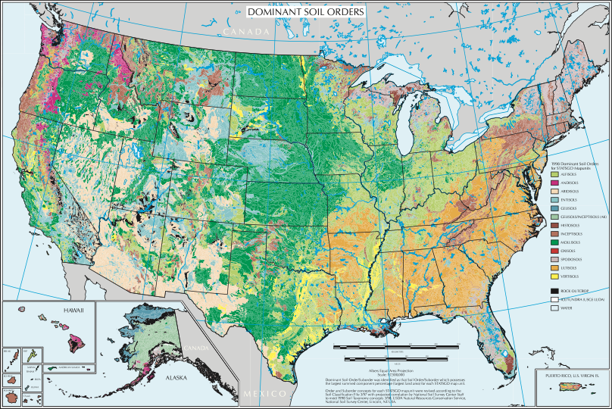metabolite composition (diversity and abundance) using state-of-the-art Fourier Transform Ion Cyclotron Resonance Mass Spectrometry (FT-ICR-MS) at the Pacific Northwest National Laboratory. Finally, we will measure multiple geochemical parameters that have been shown to influence microbial community composition, but have not yet been linked with metabolite composition or microbial function. By leveraging multivariate statistical approaches and machine-learning, we will identify patterns in the diversity of microbial communities and the molecular composition of metabolites they produce. Based on the current level of interest in the field, I will help co-author a manuscript we aim to submit for publication in  *Nature Geosciences.*

**Budget & Project Timeline**

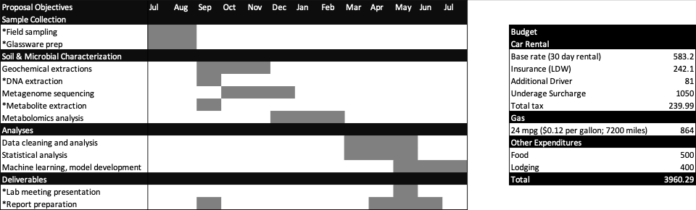

*Led by Manya Weintraub

I have qualified for Federal Work Study and my award will be matched by Dr. Lehmann, who will also cover soil shipping costs, DNA extraction and sequencing, and geochemical analyses. Dr. Lehmann has an additional grant proposal under review with the Department of Energy intended to cover additional analytical costs as they arise. Funding awarded through this application will cover car rental, insurance, and fuel costs for the trip (please see proposed budget above).

Literature Cited

Cotrufo, M.F., Wallenstein, M.D., Boot, C.M., Denef, K., Paul, E.A., 2013. The Microbial Efficiency-Matrix Stabilization (MEMS) framework integrates plant litter decomposition with soil organic matter stabilization: Do labile plant inputs form stable soil organic matter? Global Change Biology 19, 988–995. doi:10.1111/gcb.12113

Doetterl, S., Berhe, A.A., Arnold, C., Bodé, S., Fiener, P., Finke, P., Fuchslueger, L., Griepentrog, M., Harden, J.W., Nadeu, E., Schnecker, J., Six, J., Trumbore, S., Van Oost, K., Vogel, C., Boeckx, P., 2018. Links among warming, carbon and microbial dynamics mediated by soil mineral weathering. Nature Geoscience 11, 589–593. doi:10.1038/s41561-018-0168-7

Doetterl, S., Stevens, A., Six, J., Merckx, R., Van Oost, K., Casanova Pinto, M., Casanova-Katny, A., Muñoz, C., Boudin, M., Zagal Venegas, E., Boeckx, P., 2015. Soil carbon storage controlled by interactions between geochemistry and climate. Nature Geoscience 8, 780–783. doi:10.1038/ngeo2516

Fierer, N., Bradford, M.A.., Jackson, R.B., 2016. Toward an Ecological Classification of Soil Bacteria. Ecology 88, 1354–1364. doi:10.1890/05-1839

Hall, E.K., Bernhardt, E.S., Bier, R.L., Bradford, M.A., Boot, C.M., Cotner, J.B., del Giorgio, P.A., Evans, S.E., Graham, E.B., Jones, S.E., Lennon, J.T., Locey, K.J., Nemergut, D., Osborne, B.B., Rocca, J.D., Schimel, J.P., Waldrop, M.P., Wallenstein, M.D., 2018. Understanding how microbiomes influence the systems they inhabit. Nature Microbiology 3, 977–982. doi:10.1038/s41564-018-0201-z

Kaiser, K., Kalbitz, K., 2012. Cycling downwards - dissolved organic matter in soils. Soil Biology and Biochemistry 52, 29–32. doi:10.1016/j.soilbio.2012.04.002

Keiluweit, M., Bougoure, J.J., Nico, P.S., Pett-Ridge, J., Weber, P.K., Kleber, M., 2015. Mineral protection of soil carbon counteracted by root exudates. Nature Climate Change 5, 588–595. doi:10.1038/nclimate2580

Kellerman, A.M., Dittmar, T., Kothawala, D.N., Tranvik, L.J., 2014. Chemodiversity of dissolved organic matter in lakes driven by climate and hydrology. Nature Communications 5, 1–8. doi:10.1038/ncomms4804

Lehmann, J., Kleber, M., 2015. The contentious nature of soil organic matter. Nature 528, 60–68. doi:10.1038/nature16069

Lehmann, J., Solomon, D., Kinyangi, J., Dathe, L., Wirick, S., Jacobsen, C., 2008. Spatial complexity of soil organic matter forms at nanometre scales. Nature Geoscience 1, 238–242. doi:10.1038/ngeo155

Li, H.Y., Wang, H., Wang, H.T., Xin, P.Y., Xu, X.H., Ma, Y., Liu, W.P., Teng, C.Y., Jiang, C.L., Lou, L.P., Arnold, W., Cralle, L., Zhu, Y.G., Chu, J.F., Gilbert, J.A., Zhang, Z.J., 2018. The chemodiversity of paddy soil dissolved organic matter correlates with microbial community at continental scales. Microbiome 6, 1–16. doi:10.1186/s40168-018-0561-x

Liang, C., Schimel, J.P., Jastrow, J.D., 2017. The importance of anabolism in microbial control over soil carbon storage. Nature Microbiology 2, 17105. doi:10.1038/nmicrobiol.2017.105

Lynch, L.M., Machmuller, M.B., Boot, C.M., Covino, T.P., Rithner, C.D., Cotrufo, M.F., Hoyt, D.W., Wallenstein, M.D., 2019. Dissolved organic matter chemistry and transport along an Arctic tundra hillslope. Global Biogeochemical Cycles.

Miltner, A., Bombach, P., Schmidt-Brücken, B., Kästner, M., 2012. SOM genesis: Microbial biomass as a significant source. Biogeochemistry 111, 41–55. doi:10.1007/s10533-011-9658-z

Paustian, K., Lehmann, J., Ogle, S., Reay, D., Robertson, G.P., Smith, P., 2016. Climate-smart soils. Nature 532, 49.

Soares, M., Rousk, J., 2019. Microbial growth and carbon use efficiency in soil: Links to fungal-bacterial dominance, SOC-quality and stoichiometry. Soil Biology and Biochemistry 131, 195–205. doi:10.1016/j.soilbio.2019.01.010